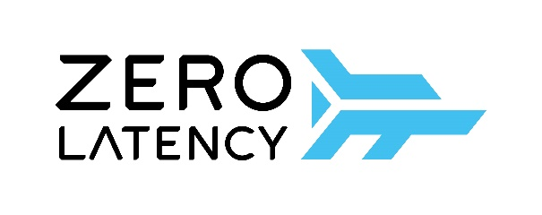
FOR IMMEDIATE RELEASE

ZOMBIES DESCEND ON MACAU

Macau’s First Free-roam, Multiplayer Virtual Reality Experience Comes to the Rescue this summer

(Hong Kong – 6 June 2018) Giving the Las Vegas of Asia a run for its money, Zero Latency is bringing the ultimate group entertainment experience to Macau this summer.
The pioneer and global leader in out-of-home, free-roam virtual reality (VR) entertainment, is coming to the Broadway Macau in a 200 square metre epic-scale virtual reality game arena, featuring heart racing zombie attacks, galaxy space missions and family fun adventures for up to eight players at one time*.
The new Macau location will be Zero Latency’s nineteenth location worldwide and will hold a warehouse-scale and free-moving gaming environment. Zero Latency is bringing VR to a new level and unlike other experiences where players are tethered or ‘tied’ to a computer or console, players can freely explore and fight together through wildly different and hyper-realistic virtual environments.
Experiences include:
Engineerium – A puzzle game that is perfect for first-timers and virtual reality experimenters. Players can ease into VR and the game with friends through this fantasy world that combines platform and maze challenges.
Zombie Survival – An intense, undead-themed VR shooter game, where players are bunkered in a fort and surrounded by masses of zombies; the aim is to stay alive until the rescue team comes in for rescue; an experience for thrill seekers.
Singularity – An immersive space-themed shooter game in which players are in a fight against killer robots and rogue drones, this game will take gamers into a world to investigate a secret military space station and take on the Terminators.
Within minutes, players will become fully immersed and lose all sense of reality; they will see each other as full-motion avatars, allowing them to inhabit the same physical and virtual space to talk with friends and come up with plans to take down the opposition.
Zero Latency will get players’ hearts pounding and adrenaline flowing in one incredible virtual reality experience. The countdown begins!
* Minimum age, from 16 years
Watch the Teaser Now

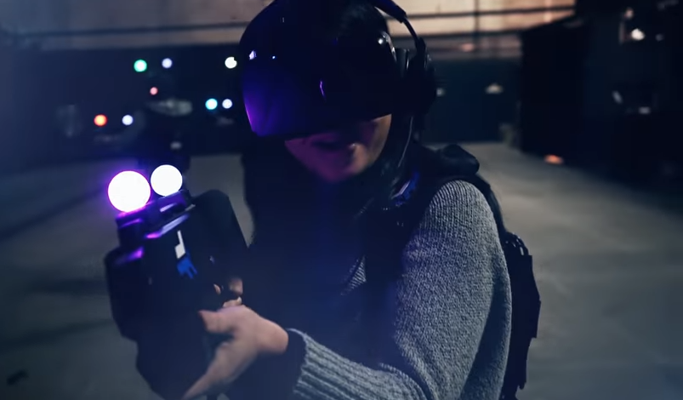

[ENDS]

Issued by GHC Asia on behalf of Tomorrow Entertainment
For media enquiries, kindly contact:
Fontaine Cheng | (852) 2810 0532 | fontaine.cheng@ghcasia.com

About Zero Latency:
Zero Latency is the pioneer and global leader in out-of-home free-roam VR entertainment. The Melbourne, Australia, based company has constructed warehouse-scale VR game arenas as free-standing locations and has also integrated them into resorts, family entertainment centres, go karting facilities, and other entertainment destinations.

There are currently 18 (soon to be 19) Zero Latency venues operating across 4 continents. There are 8 Zero Latency arenas in operation across the United States, in addition to locations in Tokyo, Osaka, Madrid, Lisbon, Mexico City, Kuala Lumpur, Singapore, Busan, Brisbane and Melbourne. Zero Latency was named by Fast Company as one of the Top 10 Most Innovative Gaming companies.

For more information, please visit: http://zerolatencyvrmacau.com

